AI FitTrack API
Team ID:
SWTID-2026-7441
Team Leader:
BHAVANI.C (C24UG152CSC013)
Team members:
MONISHA.M (C24UG152CSC044)
YESASWINI.P (C24UG152CSC087)
SATHYA.P (C24UG152CSC069)
PROJECT OVERVIEW
FitTrack AI is a secure and scalable AI-powered fitness management backend developed using Node.js, Express.js, MongoDB, and Mongoose. The system provides RESTful APIs for user authentication, workout management, workout searching, and personalized fitness recommendations.
The application follows the Model-View-Controller (MVC) architecture, which makes the system modular, maintainable, and easy to extend. JWT authentication is used to protect user accounts and workout data, while bcrypt.js securely hashes passwords before storing them in the database.
A major feature of FitTrack AI is its integration with Google Gemini AI. The AI analyzes user details such as age, fitness goals, and experience level to generate personalized workout recommendations, weekly exercise suggestions, motivational guidance, and safety tips. It can also analyze workout statistics such as workout count, duration, and calories burned to provide useful fitness insights.
The backend supports complete CRUD operations for workout records, allowing users to create, view, update, delete, and search their workouts. Input validation, protected routes, centralized error handling, and standardized JSON responses improve the reliability and security of the application.
Overall, FitTrack AI provides a centralized and intelligent platform for managing fitness activities and receiving personalized workout guidance. Its modular architecture also allows future enhancements such as nutrition tracking, BMI calculation, wearable-device integration, workout reminders, and fitness analytics dashboards.
1. Software Requirements
The FitTrack AI requires the following software components for development and execution.Operating System: Windows 10/11, macOS, or Linux (supports cross-platform operations).
- Node.js (v16 or above): Runtime ecosystem running server logic and routing infrastructure.
- npm (v8 or above): Node package manager to control operational dependencies.
- Express.js: Lightweight routing web framework to construct backend RESTful entry points.
- MongoDB: Document NoSQL engine storing users, posts, categories, comments, and analytics metrics.
- Postman: API verification toolkit to assert schema validation responses across administrative route shields.
- Code Editor: Visual Studio Code or similar IDE environment.
2. Hardware Requirements
- Processor: Intel Core i5 (8th Gen or above) / AMD Ryzen 5 or equivalent.
- RAM: 8 GB minimum (16 GB recommended for concurrent instances of MongoDB, processing layers, and execution nodes).
- Storage: 1 GB of available disk workspace.
Epic 1: Project Architecture
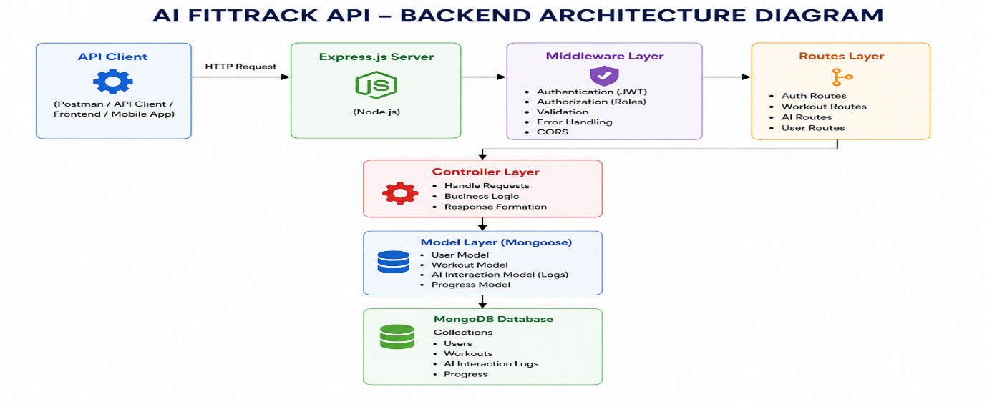
PROJECT ARCHITECTURE
FitTrack AI follows a layered MVC (Model–View–Controller) architecture that separates routing, authentication, business logic, database operations, and AI services. This makes the system secure, modular, maintainable, and scalable.
Main Components
- Client Layer – React, mobile app, or Postman sends HTTP requests and receives JSON responses.
- Express Server – Receives requests, handles middleware, routes, CORS, and errors.
- Authentication Middleware – Validates JWT tokens and protects secured APIs.
- Route Layer – Defines APIs for user authentication, workout management, and AI features.
- Controller Layer – Processes requests, applies business logic, and returns responses.
- Service Layer – Handles reusable operations such as JWT creation, password hashing, and Google Gemini AI communication.
- Database Layer – MongoDB stores user and workout data, while Mongoose manages database operations.
ER Diagram Description
The system mainly contains Users and Workouts collections. A single user can have multiple workout records, creating a one-to-many relationship between Users and Workouts. Each workout is associated with a specific user through the user ID.
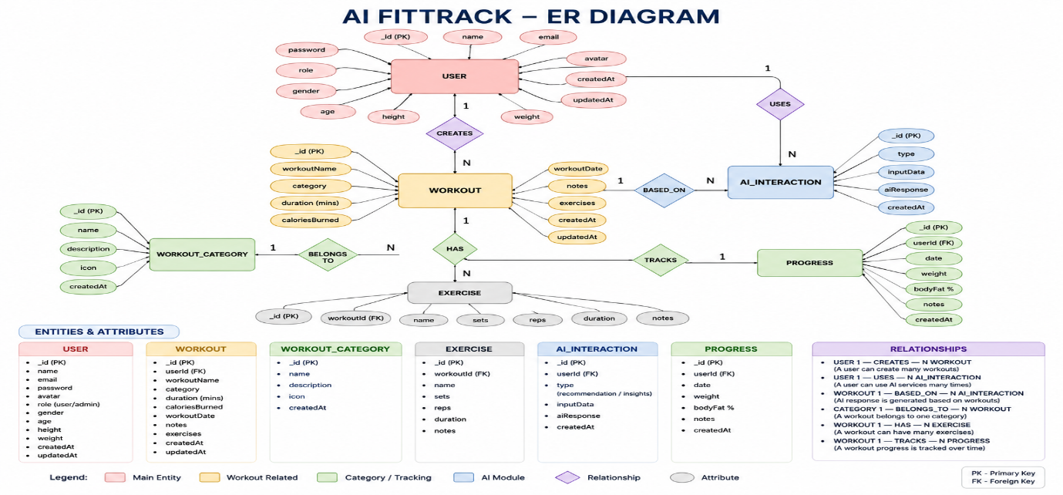
DATABASE DESIGN & FEATURES
1. User Entity
Stores user authentication details:
- Name
- Email
- Encrypted Password
- Created/Updated Date
- Unique Email and JWT Authentication
2. Workout Entity
Stores workout information:
- Workout Name
- Category
- Duration
- Calories Burned
- Workout Date
- User ID
Relationship: One User → Many Workouts.
Key Features
- Secure Authentication – Registration, login, bcrypt, and JWT.
- Workout Management – Add, view, update, and delete workouts.
- Workout Search – Search by name, category, or date.
- Gemini AI – Generates personalized workout recommendations.
- Fitness Insights – Analyzes workout statistics and provides suggestions.
- Error Handling – Handles authentication, validation, and database errors.
- RESTful API – Supports GET, POST, PUT, and DELETE.
- Modular Architecture – Uses Models, Controllers, Routes, Middleware, and Services.
User Role
The authenticated user can register, login, manage workouts, search records, and access AI recommendations and fitness insights.
User Flow
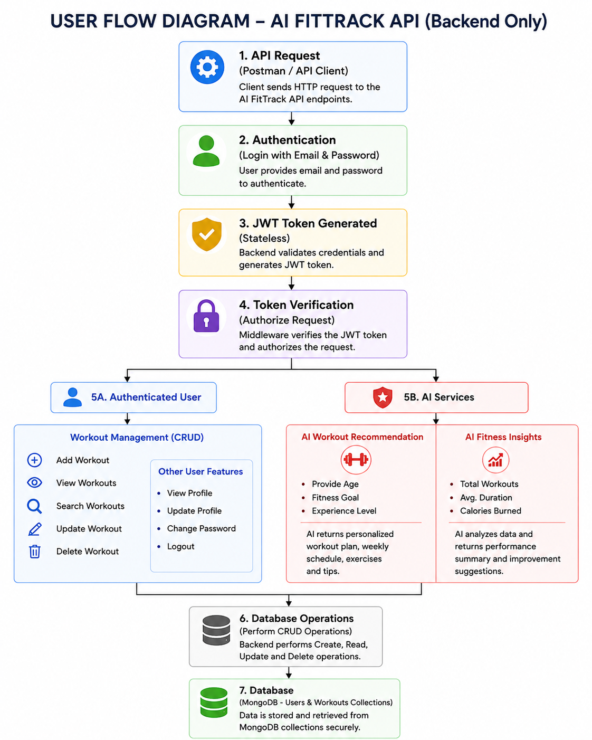

MVC Architecture Pattern
The FitTrack AI is designed using the Model–View–Controller (MVC) architecture pattern. This architecture separates application logic into independent components, improving code organization, maintainability, and scalability.
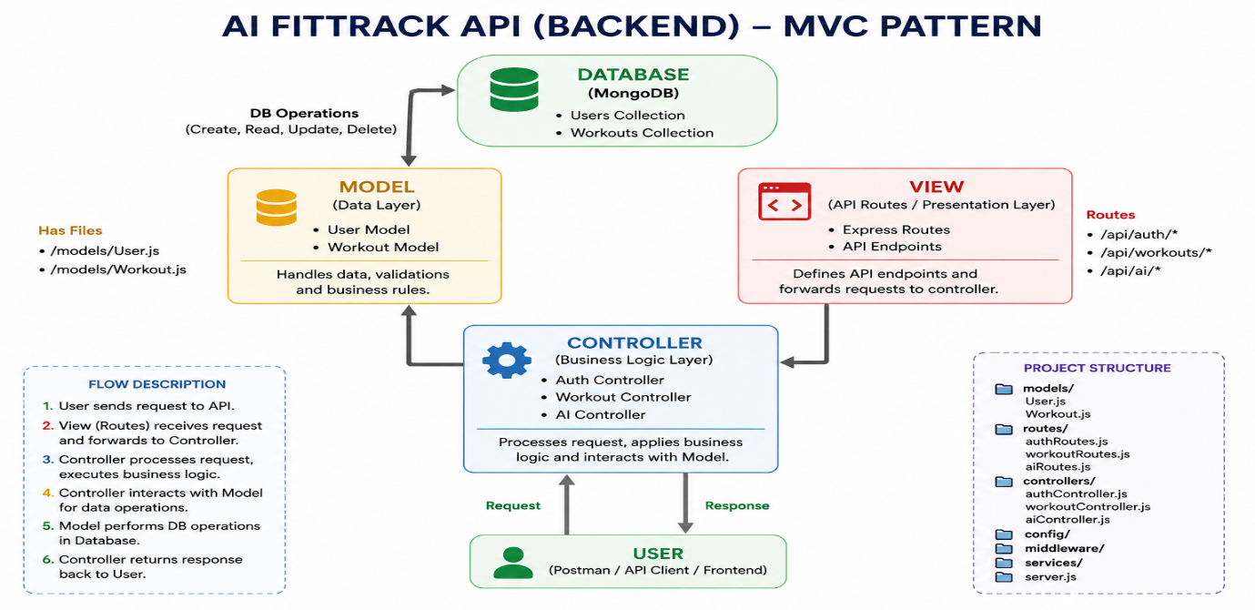
MVC LAYERS & PROJECT SETUP – SHORT VERSION
1. Model Layer
- Defines data using Mongoose schemas.
- Communicates with MongoDB.
- Handles validation and CRUD operations.
- Includes User and Workout models.
2. View Layer
- No traditional UI templates.
- React, mobile apps, or Postman act as API consumers.
- Sends requests and receives JSON responses.
3. Controller Layer
- Handles business logic.
- Validates requests.
- Communicates with models and AI services.
- Returns responses to the client.

Epic 2: Project Setup
- Create AI-FitTrack-API folder.
- Create server folder.
- Initialize Node.js using npm init -y.
- Install Express, Mongoose, dotenv, bcryptjs, JWT, CORS, and Nodemon.
- Store sensitive information in .env.
Epic 3: Backend Development
Main modules:
- Server Configuration
- Database Configuration
- Authentication
- Workout Management
- AI Recommendation
Epic 4: Database Configuration
- Uses MongoDB as the database.
- Mongoose connects Node.js with MongoDB.
- Main collections: Users and Workouts.
- Supports schema validation and CRUD operations.
Responsibilities
- Connect to MongoDB
- Handle Connection Errors
- Display Connection Status
- Export Database Connection
Advantages
- Centralized database configuration
- Reusable connection module
- Automatic connection management
- Simplified error handling

Mongoose Schemas
The AI FitTrack backend contains two primary Mongoose schemas:
- User Schema
- Workout Schema
Schemas define the structure, validation rules, and relationships for MongoDB documents.
1. User Schema (models/User.js)
The User schema stores authentication information for registered users.
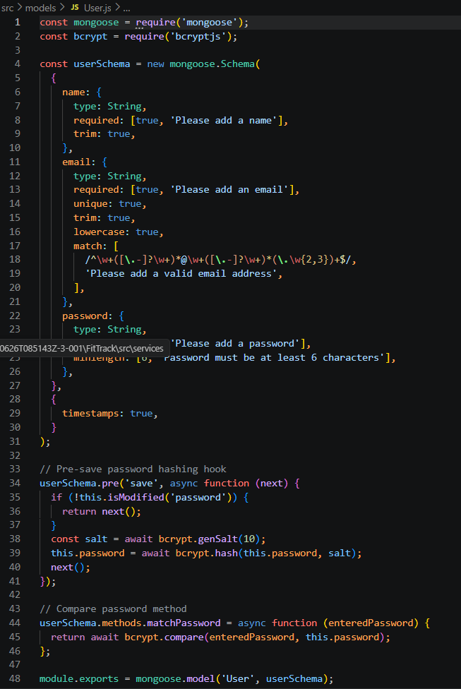Validation Rules
- Name cannot be empty.
- Email must be unique.
- Password is mandatory.
- Password is encrypted using bcrypt.js before saving.
- Automatic timestamps are enabled.
User Schema Features
- Email uniqueness validation
- Password hashing
- Automatic timestamps
- Secure authentication support
- JWT integration
2. Workout Schema (models/Workout.js)
The Workout schema stores workout information created by authenticated users.
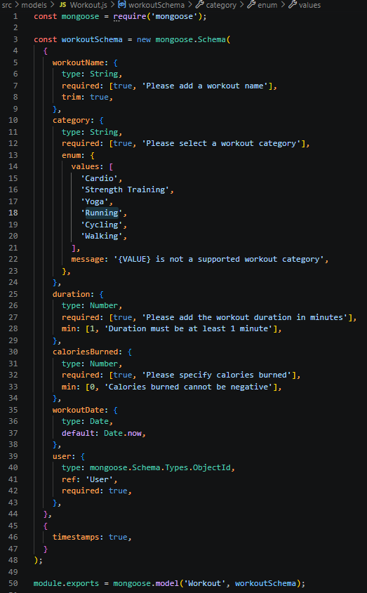
Validation Rules
- Workout Name is mandatory.
- Category is mandatory.
- Duration must be greater than zero.
- Calories Burned must be greater than or equal to zero.
- Workout Date is required.
- Every workout belongs to one authenticated user.
Workout Schema Features
- Schema validation
- Automatic timestamps
- User relationship
- Easy search support
Epic 5: Project Execution
· Install Postman or ThunderClient (VS Code extension).
· Start the backend server:
“npm start”
API Testing
API testing ensures that every endpoint functions correctly and returns the expected response. The FitTrack AI is tested using Postman, allowing developers to verify request handling, authentication, database operations, and AI integration.
Testing is performed in the following order:
- Authentication APIs
- Workout APIs
- AI APIs
Authentication API Testing
Register User
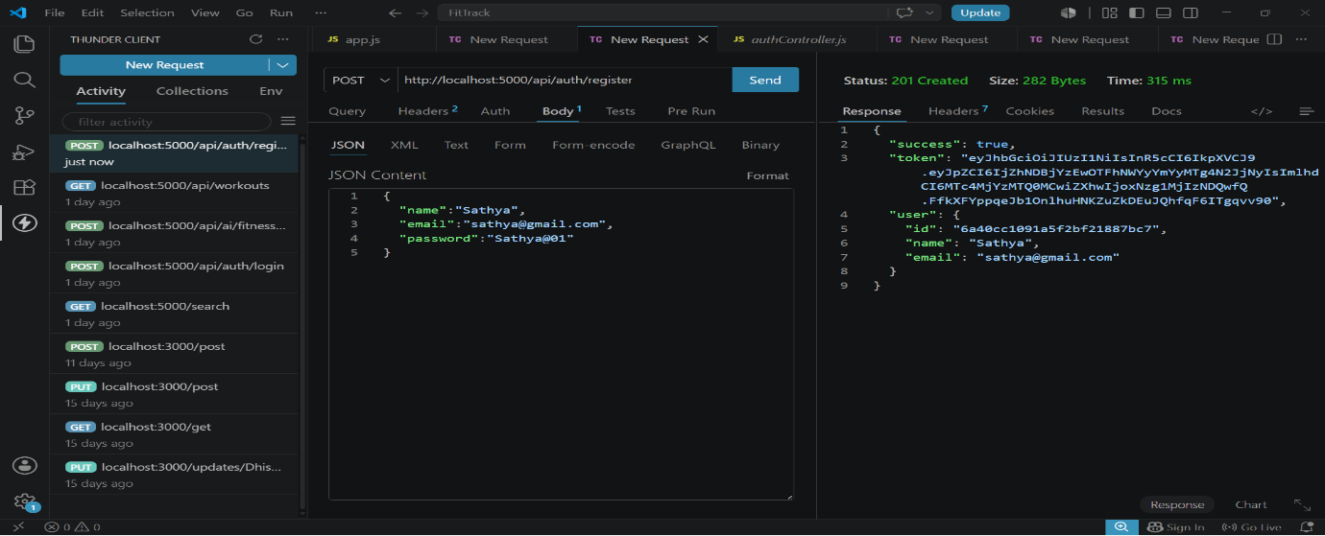
Login User
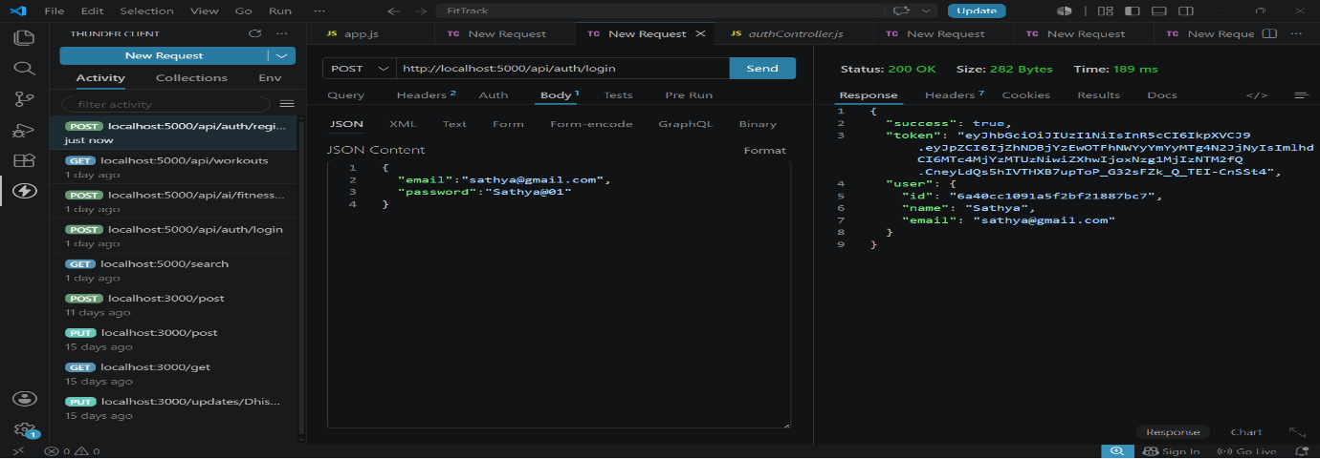
Get Profile
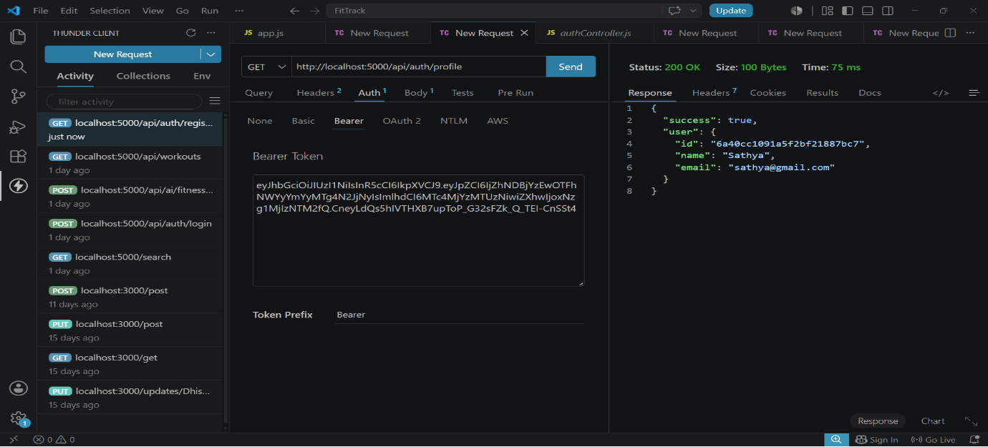
Workout API Testing
Add Workout
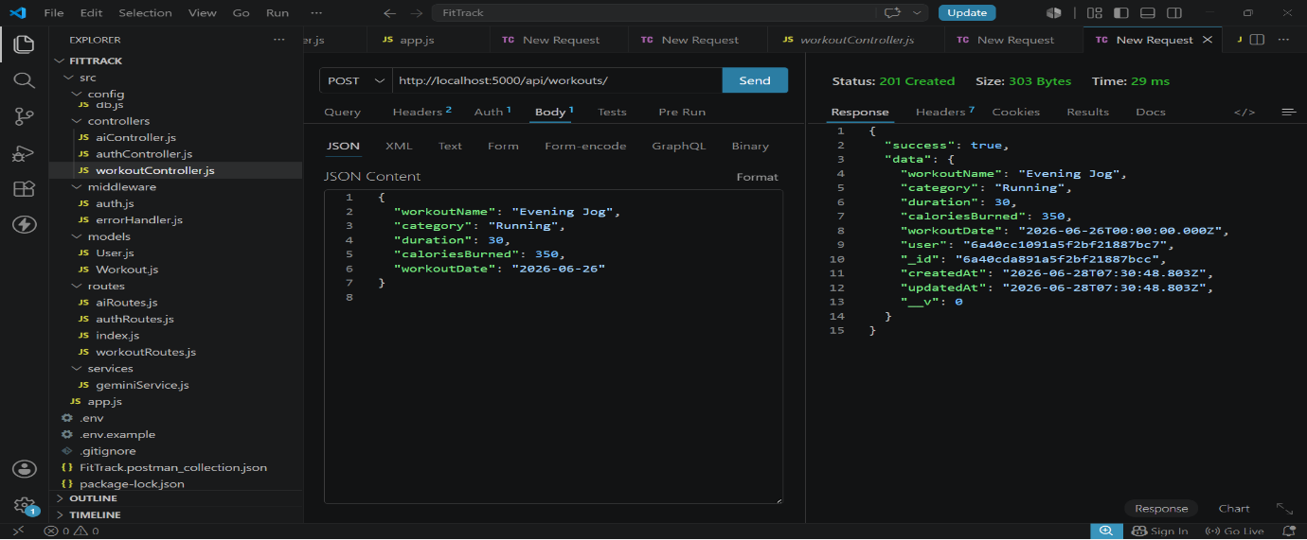
Get All Workouts
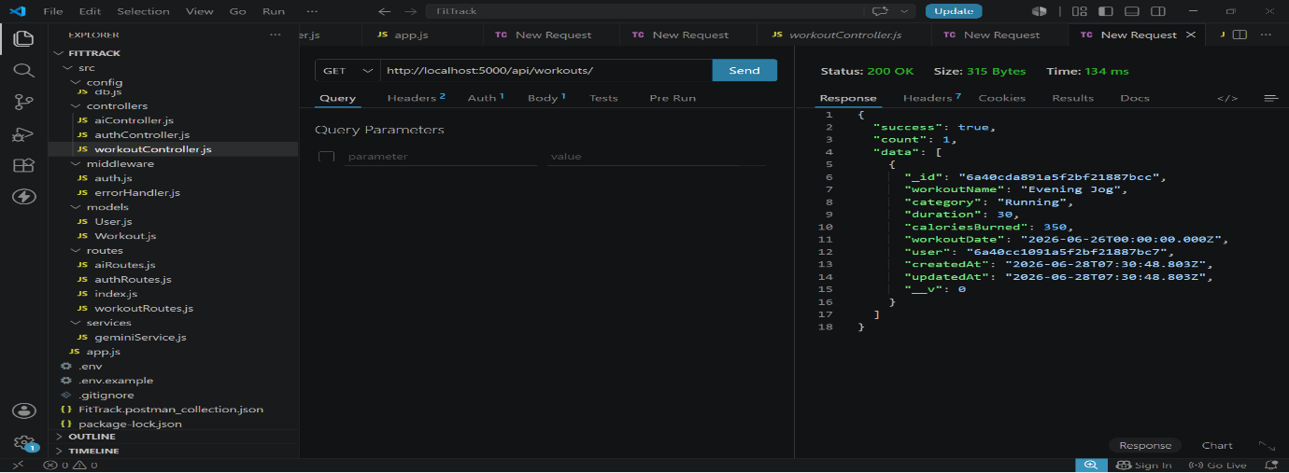
Get Workout By ID
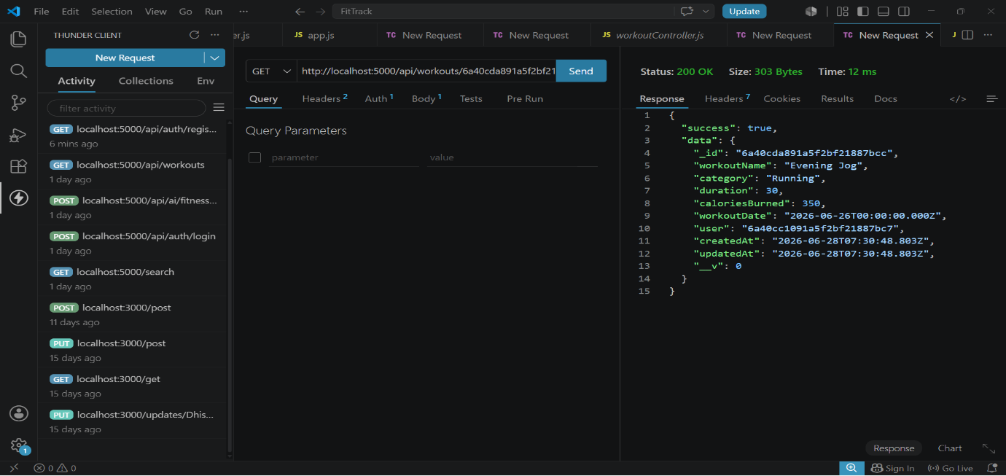
Update Workout
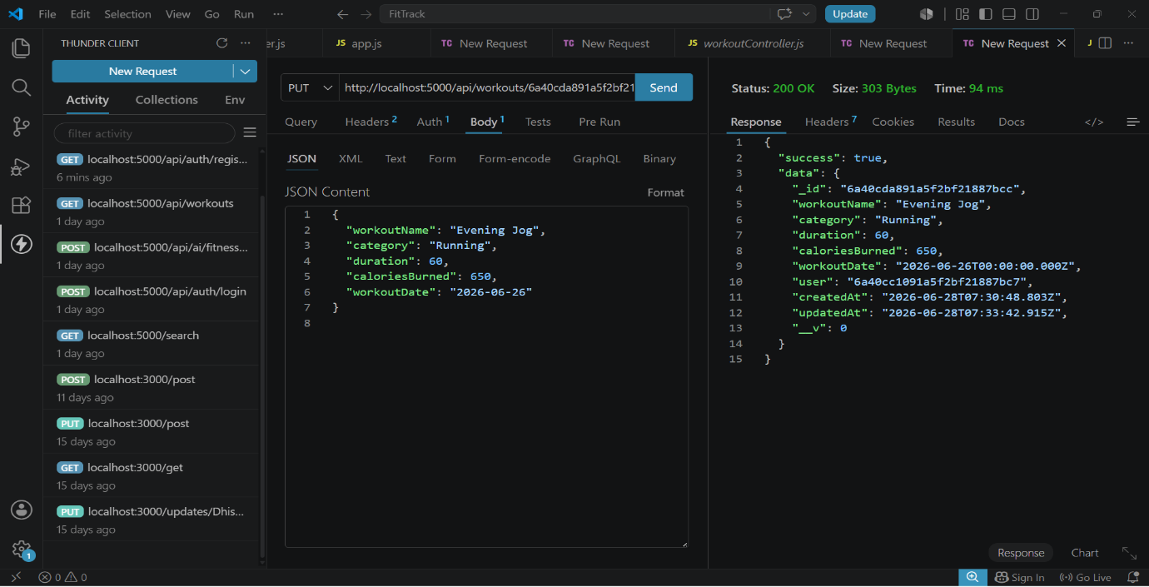
Delete Workout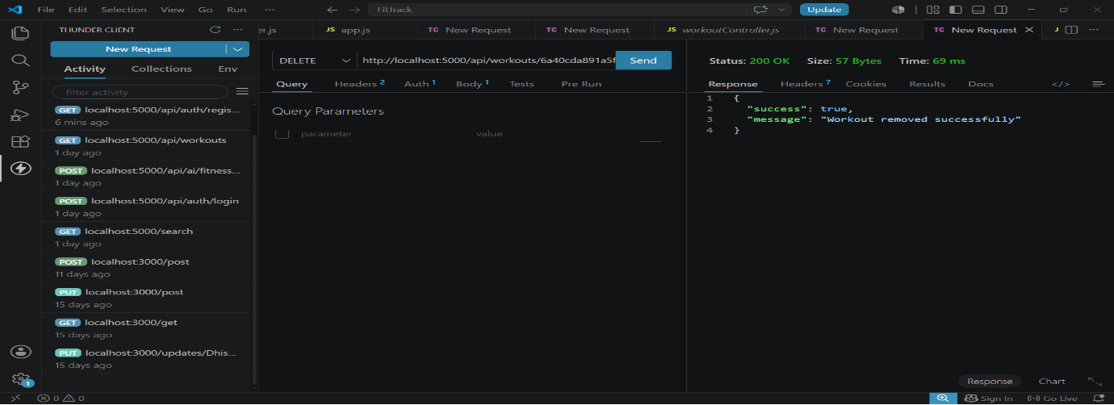
AI API Testing
Workout Recommendation
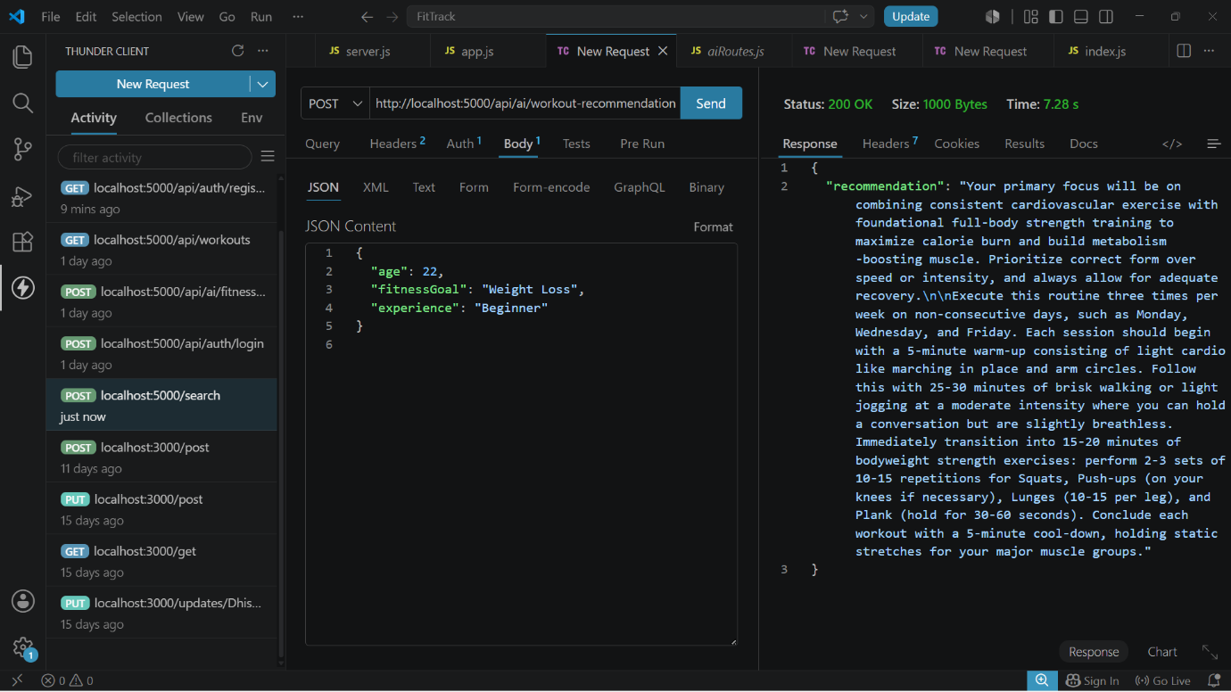
Fitness Insights
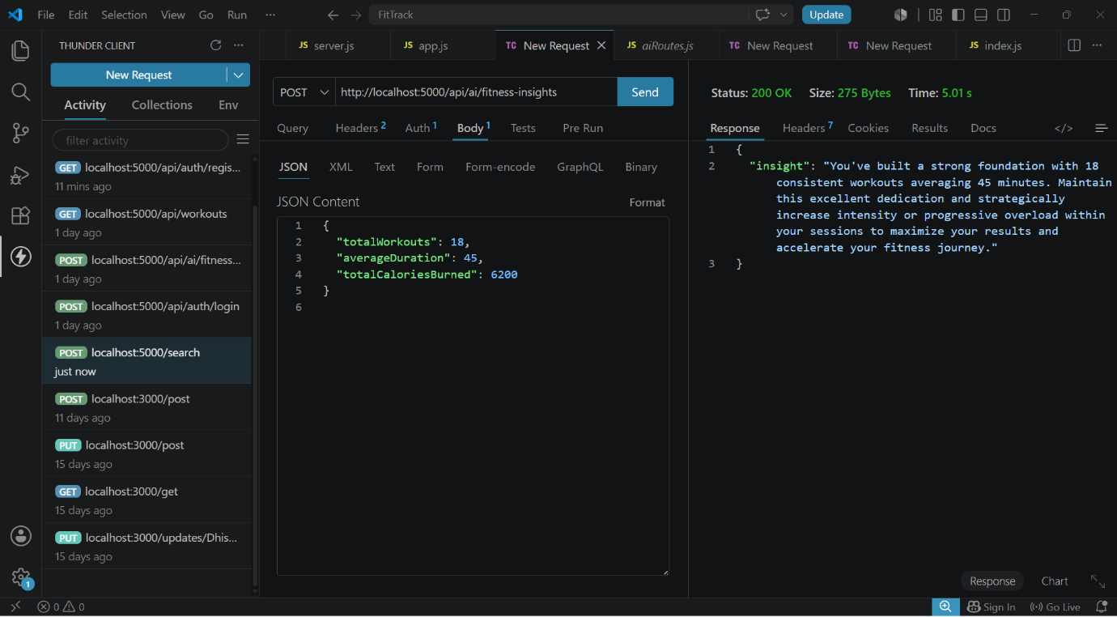
Demo Video Link: https://drive.google.com/file/d/1KswrctSaPI0eOYyJ3GkbbVHvHsU3EfZJ/view?usp=drive_link
CodeDrive:https://drive.google.com/drive/folders/1hwmKxkHQkUI62JR1svI3xCQ2ShZ6Lj9y.

